**TASK 4 – OUTPUT SCREENSHOTS**

**--1. Create a database**

-- CREATE DATABASE SalesDatabase;

-- Connect to the SalesDatabase

**-- Create the sales_sample table**

CREATE TABLE sales_sample (

Product_Id INTEGER,

Region VARCHAR(50),

Date DATE,

Sales_Amount NUMERIC

);

**--2. Insert 10 sample records into the "sales_sample" table**

INSERT INTO sales_sample (Product_Id, Region, Date, Sales_Amount)

VALUES

(1, 'East', '2023-01-05', 1000.50),

(2, 'West', '2023-01-10', 750.25),

(1, 'North', '2023-01-15', 1250.75),

(3, 'South', '2023-01-20', 600.00),

(2, 'East', '2023-02-05', 850.60),

(3, 'West', '2023-02-10', 1100.25),

(1, 'North', '2023-02-15', 950.40),

(2, 'South', '2023-02-20', 1150.75),

(3, 'East', '2023-03-05', 700.25),

(1, 'West', '2023-03-10', 1020.90);

**-- 3. Perform OLAP operations**

**-- a. Drill Down - Analyze sales data at a more detailed level (Region to Product).**

-- This query will show sales performance for each product within each region.

SELECT Region, Product_Id, SUM(Sales_Amount) AS Total_Sales

FROM sales_sample

GROUP BY Region, Product_Id

ORDER BY Region, Product_Id;

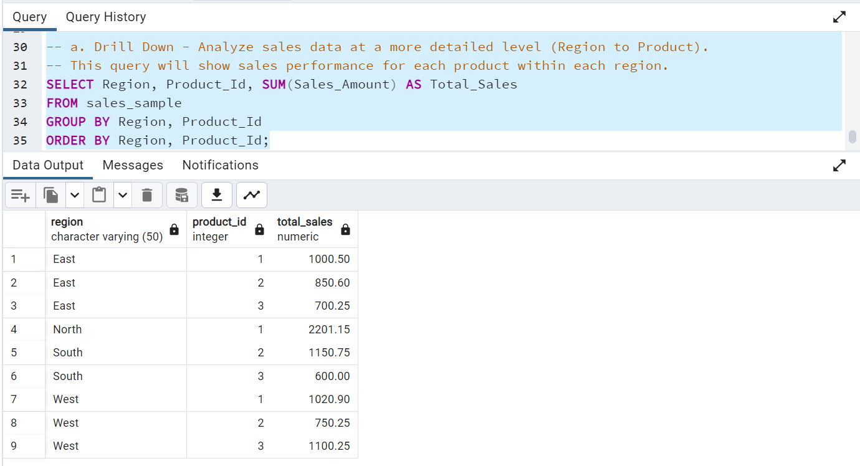

**-- b. Rollup - Summarize sales data at different levels of granularity (Product to Region).**

-- This query will show the total sales for each region, aggregating at the region level.

SELECT Region, SUM(Sales_Amount) AS Total_Sales

FROM sales_sample

GROUP BY Region

ORDER BY Region;

**-- c. Cube - Analyze sales data from multiple dimensions simultaneously.**

-- This query explores sales data from different perspectives: product, region, and date.

SELECT Region, Product_Id, Date, SUM(Sales_Amount) AS Total_Sales

FROM sales_sample

GROUP BY CUBE (Region, Product_Id, Date)

ORDER BY Region, Product_Id, Date;

**-- d. Slice - Extract a subset of data based on specific criteria (e.g., sales for a particular region or date range).**

-- This query slices the data to view sales for the "East" region and a specific date range.

SELECT Region, Date, SUM(Sales_Amount) AS Total_Sales

FROM sales_sample

WHERE Region = 'East' AND Date BETWEEN '2023-01-01' AND '2023-03-31'

GROUP BY Region, Date

ORDER BY Date;

**-- e. Dice - Extract data based on multiple criteria (specific combinations of product, region, and date).**

-- This query views sales for specific combinations of product, region, and date.

SELECT Region, Product_Id, Date, SUM(Sales_Amount) AS Total_Sales

FROM sales_sample

WHERE (Region = 'East' OR Region = 'West') AND (Product_Id = 1 OR Product_Id = 2) AND Date = '2023-02-15'

GROUP BY Region, Product_Id, Date

ORDER BY Region, Product_Id, Date;

